**AI ASSISTED CODING **

***LAB-3.2: Prompt Engineering – Improving Prompts and Context Management***

**ROLL NO: 2503A51L06**

**NAME: D. NAGAMRUTHA**

**BATCH:** **25BTCAICSB19**

**TASK#1:**

**Prompt: -** write a function to calculate compound interest, starting with only the function name. Then add a docstring, then input-output example.

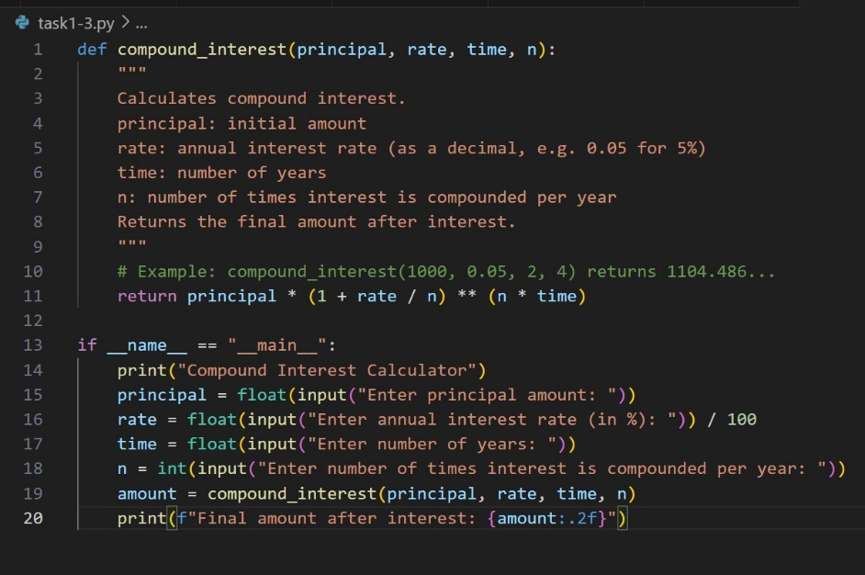**Code Generated:**

**Output:**

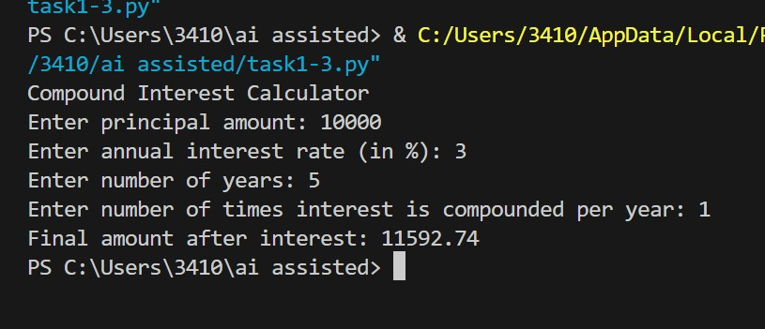

**Observation:** This code defines a Compound Interest Calculator in Python. It uses a function compound interest() that applies the standard compound interest formula to calculate the final amount based on the principal, annual interest rate, time period, and compounding frequency. In the main section, the program takes user input for these values, performs the calculation, and neatly displays the result rounded to two decimal places. It is a simple,interactive, and practical implementation.

**Task#2:**

**Prompt: - #**Write a function to calculate average, median, and mode of a list of numbers.

**Code Generated:**

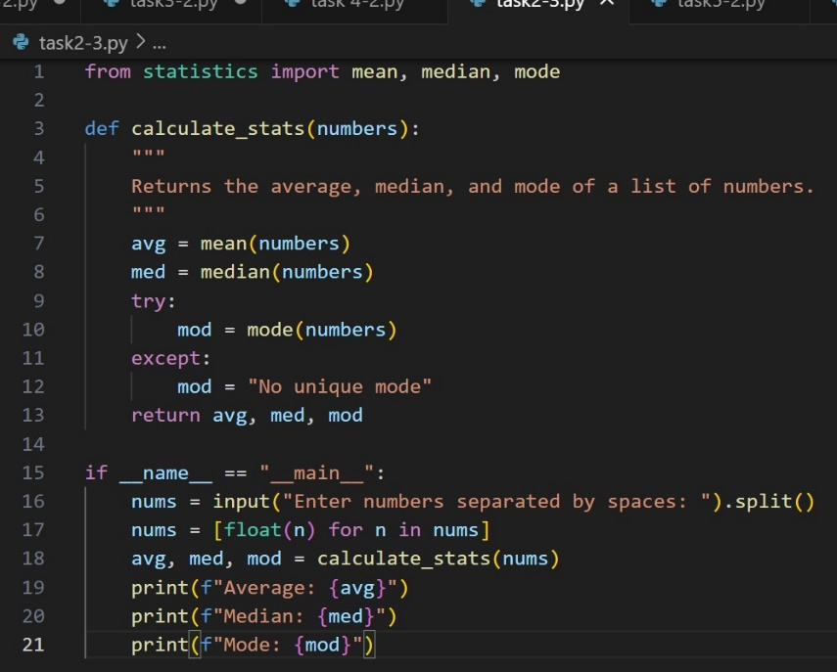

**Output:**

**Observation:**

This code is a Statistics Calculator that computes the average, median, and mode of a list of numbers. It uses Python’s statistics module for calculations and handles cases where no unique mode exists by displaying a custom message. The program takes space-separated numbers as input from the user, converts them into floats, and then outputs the calculated results in a clear format. It is a simple and effective implementation for basic statistical analysis.

**Task#3:**

**Prompt:**

Provide multiple examples of input-output to the AI for convert _to_ binary (num) function.

**Code Generated:**

**Output:**

**Observation:**

By providing multiple input–output examples for the convert _to_ binary(num) function, I noticed how AI applied few-shot prompting to generalize and generate correct binary conversions for any decimal input**.**

**Task#4:**

**Prompt:**

Create an user interface for a hotel to generate bill based on customer requirements.

**

**Output:**

**Observation:**

This code is a Hotel Billing System that generates a detailed bill for a customer. It collects inputs such as customer name, room type, number of nights, food bill, and other charges. Based on predefined room rates, it calculates the room cost and adds all expenses to determine the total bill. The program validates the room type and then neatly displays the complete bill summary, making it a simple and practical billing solution.

**Task#5:**

**Prompt:**

Analyzing Prompt Specificity: Improving Temperature Conversion Function with Clear Instructions

**Code Generated:**

**Output:**

**Observation:**

This code is a Temperature Converter that allows conversion between Celsius, Fahrenheit, and Kelvin. It uses conditional logic to apply the correct conversion formula based on the chosen units and returns the converted value. The program takes user input for temperature, source unit, and target unit, then displays the result with two decimal precision or shows an error message for invalid conversions. It is a clear and functional implementation for basic temperature conversions.